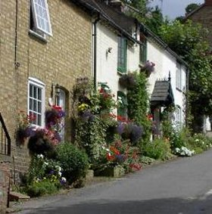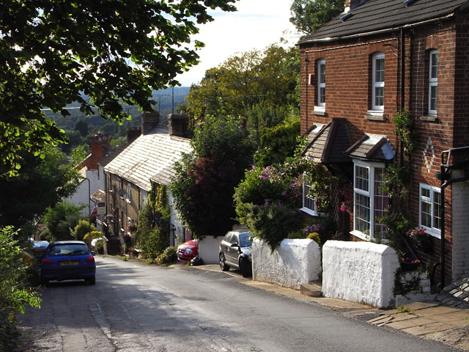

Unitary Councillors Report to Bow Brickhill – November 2025
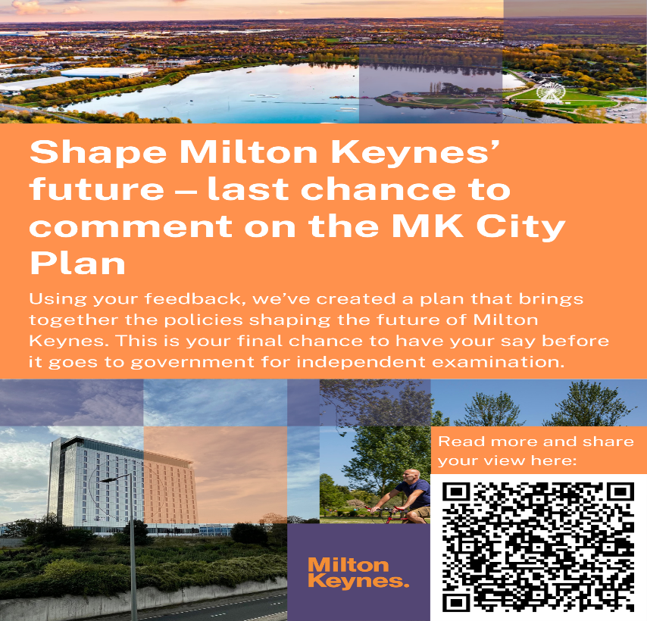 Reminder: MK City Plan 2050 Information Session

MKCC held an MK City Plan 2050 information session in the city council chamber on Wednesday 5 November for Ward Councillors and members of Town and Parish Councils. This event was not open to members of the public. The session covered details about the final draft of the MK City Plan and its consultation.

Relevant papers at … https://milton-keynes.moderngov.co.uk/ieListDocuments.aspx?CId=154&MId=7662

________________________________________
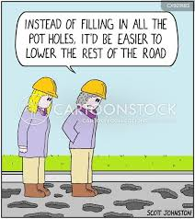 Highways Maintenance in Bow Brickhill

For information, MK City Council currently has six open enquiries for the Bow Brickhill area which it is working on.

This includes 5 pothole / surfacing reports and 1 blocked gully.

The reported potholes will be checked by one of the MKC Highways inspectors shortly who will assess whether a repair is required based on the Codes of Practice criteria.

For blocked gullies, unless there are reports/evidence of localised flooding in an area, the gully will be checked and cleansed as part of the city council’s routine maintenance.

All areas are assessed based on evidence we have which may be flooding reports, photos, site visits etc. After an assessment has been made, the enquiry will be either Critical, High, Moderate or Low Risk.

Critical areas: will be visited twice a year to make sure all the roadside gullies are working to capacity.

- High Risk: will be done once every two years.
- Medium Risk: will be done every four years.
- Low Risk: MKCC will attend once within a six year period.

The A5 works by National Highways in nearby Little Brickhill parish continue along the section between Kellys Kitchen Roundabout and Thorn Roundabout. All the permit info including the dates are on www.one.network

Friends of Bow Brickhill Station supported by Marston Vale
CRP
• “I appreciate these colours every time I pass through! Thank you for the effort.”
Regular passenger
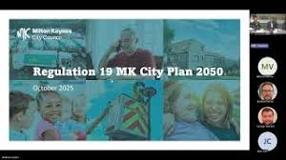

Local Plan Moves to next stage of ‘Consultation’ – MK2050

The relevant Cabinet Member took a delegated decision to move to the ‘Regulation 19’ Stage of the process on 28 October.
The ‘consultation’ will run through November and December. the consultation is being scheduled to commence next week (likely to be Friday 7th November) and closes on Monday 22 December.

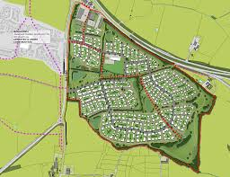 Levante Gate (in Little Brickhill Parish 1,250 dwellings and South of Bow Brickhill 1,300 dwellings) remain in the plan and will now almost certainly be included in the report that passes before the Planning Inspector in the Spring of 2026 for final approval)

These reports set out the current position of the MK City Plan 2050. Public consultation on the draft (Regulation 18) MK City Plan 2050 was completed in October 2024 and
the plan has subsequently been revised to take account of relevant responses, updates to evidence base studies and revised national planning policy.

Following endorsement of the proposed policy, which includes consideration by Environment and Place Scrutiny Committee on 8 October 2025, it is recommended
that the Proposed Submission (Regulation 19) MK City Plan 2050 is published for public consultation for six weeks. This consultation will be carried out in accordance
with the Statement of Community Involvement and an updated Local Development Scheme, which is also recommended for approval.

Following completion of the Regulation 19 consultation, the plan and all consultation responses can be submitted to the Secretary of State in March 2026. The Secretary of
State will then appoint an independent Planning Inspector to hold an Examination in Public and determine whether the plan meet legal requirements and national policy
and can be adopted.

See also https://milton-keynes.moderngov.co.uk/ieListDocuments.aspx?MId=7662&x=1

The City Council Cabinet member resolved that the recommendations of the Environment and Place Scrutiny Committee as set out in section 3.13 of this report be noted and…..

- That the Proposed Submission MK City Plan 2050 (Annex A), incorporating the changes to the plan in Annex B, and associated documents[1] be approved for a six-week public consultation in accordance with Regulation 19 of the Town and Country Planning (Local Development) (England) Regulations 2012 (as amended).

- That the Director of Planning and Placemaking be delegated authority to make minor typographical corrections to the Proposed Submission (Regulation 19) MK City Plan 2050 prior to Regulation 19 consultation.

- That it be recommended to Council that:

(a) following the close of the Regulation 19 consultation, the Proposed Submission (Regulation 19) MK City Plan 2050 is submitted to the Secretary of State for Examination, together with the Regulation 19 representations and other required documents including any addendum to the Plan; and

(b) that authority be delegated to Director Planning and Placemaking, to make any necessary minor amendments to the Proposed Submission MK City Plan 2050 and its supporting documents, including the preparation of an addendum, to address issues raised in the Regulation 19 representations, prior to submission.

- That authority be delegated to the Director Planning and Placemaking in consultation with the Cabinet Member for Planning and Placemaking to:

(a) produce any supplementary information that may be required as part of the Examination process to complete the examination and address any issues relating to soundness and legal compliance including Statements of Common Ground with various organisations;

(b) write to the appointed Local Plan Inspector(s) to the submitted MK City Plan 2050 as may be necessary to make the Proposed Submission MK City Plan 2050 sound and legally compliant under Section 20(7C) of the 2004 Planning and Compulsory Purchase Act;

(c) agree any Main Modifications recommended by the appointed Local Plan Inspector(s)and undertake a six-week public consultation that may arise out of the Examination process; and

(d) make any necessary non-material modifications to the Proposed Submission MK City Plan 2050, Policies Map and other supporting documents during the Examination;

- That the programme of work as set out in the updated Milton Keynes Local Development Scheme (LDS) (Annex J) be approved.

- That the Director of Planning and Placemaking be delegated authority to make minor typographical corrections to the LDS prior to its publication.

Note: In accordance with Overview and Scrutiny Procedure Rules 17 (d) (i), and 17 (i) ii) decisions 2.1 - 2.4 cannot be called in.

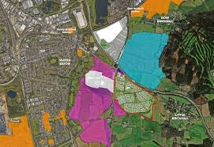

H10 Bletham Way extension

MK City Council has agreed the funding for the start of work in 2026 on the extension of the H10 in the South East Milton Keynes development area.

MK City Council is installing a Pegasus crossing at the bridleway.

There were a number of factors influencing the decision to go for this solution but the principle issue MK City Council is trying to address is to get the road elevated over Byrd Crescent, but then get it back down to existing ground levels as quickly as possible before entering the Church Farm site.

MKCC has kept the road at a sufficiently elevated level to provide a bridge over the bridleway would have meant a significant, and in their view unacceptable, level of visual and noise intrusion for properties adjacent to the existing Transport Corridor. It would have also created a significant challenge in getting the road back down to existing ground levels in order to meet the junctions serving the two Church Farm parcels.

Tunnelling under the new road to provide grade separation for the bridleway would also presented significant problems in that it may have compromised the drainage assets in the area as well as being a costly and disproportionate intervention which would also have compromised what we are trying to do in creating a form of ‘parkland in the balance of the Transport Corridor not being used for the highway.

Overall, the city council think the solution it is proposing is the better one for this location and it will keep everyone safe.

A5 Little Brickhill to Thorn Roundabout - Speed reduction changes and new speed camera locations

For the latest information, please visit our dedicated webpage https://nationalhighways.co.uk/our-roads/east/east-road-maintenance-work/
If you would like more information, please contact us on 0300 123 5000, or by email at info@nationalhighways.co.uk.
Background
A total of 44 reported injury collisions were recorded on this route over a 5-year period with 95 casualties. National Highways is proposing speed limit reductions at the following locations:
Section 1 – Little Brickhill and Hockliffe (a distance of approximately 6km)
Proposed reduction of the existing National Speed Limit (60mph) to 50mph, and speed camera enforcement equipment.
Section 2 – Hockliffe and Thorn Roundabout (a distance of approximately 1.75km)
Proposed reduction of the existing National Speed Limit (60mph) to 50mph, and speed camera enforcement equipment.
- A5 Bletcham Way Roundabout northbound exit slip road - Monday 1 and Tuesday 2 December - Traffic will need to continue northbound to Redmoor Roundabout, return southbound on the A5 to exit southbound at Bletcham Way Roundabout
- A5 Bletcham Way Roundabout southbound exit slip road - Wednesday 3 December - Traffic will need to continue southbound to Kelly’s Kitchen Roundabout, return northbound on the A5 to exit at Bletcham Way Roundabout
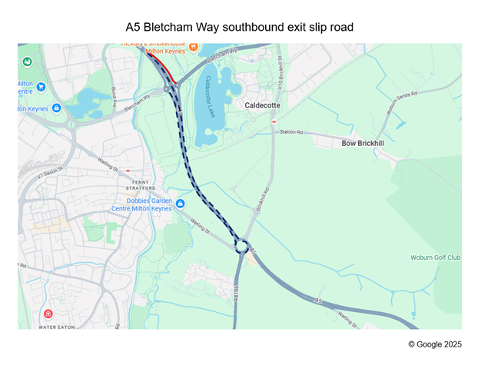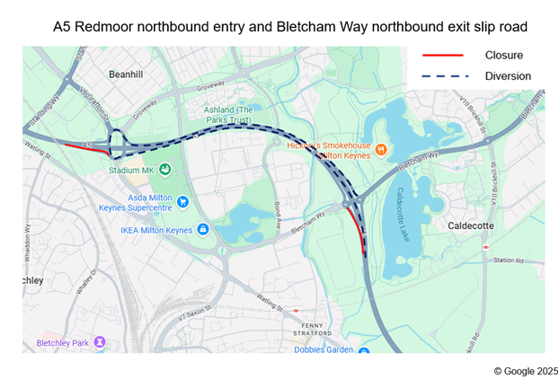

 Vehicle Crime and Tool Theft campaign launched by PCC

Matthew Barber (Police and Crime Commissioner for Thames Valley) has launched a crime prevention campaign with the aim of informing residents about how to keep vehicles and tools safe from criminals

Having your vehicle stolen or something stolen from it isn’t just an inconvenience, it can also result in financial loss, emotional stress and, depending on where the theft took place, security and community safety concerns.

In the 12 months to the end of August this year, there have been 3,496 vehicle thefts and 6,666 thefts from vehicles in the Thames Valley.

To help address this, the Office of the Police and Crime Commissioner is working with Thames Valley Police and partners, retailers and hoteliers on a campaign to raise awareness of precautions residents can take to help reduce the risk.

https://www.thamesvalley-pcc.gov.uk/vehiclecrime/
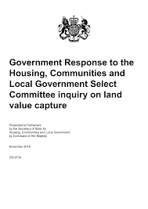 The current system of land value capture, a public finance mechanism that captures developer contributions to fund public amenities such as a new GP surgery or a school, fails to deliver the full potential funding for local communities, says the cross-party Housing, Communities and Local Government (HCLG) Committee in a report published today (Tuesday).

• The Committee report comments on the cut to London’s affordable housing target and raises concerns about the Government’s ability to meet its 1.5 million new homes target.

• Land value capture is a public finance tool that captures increases in land value following the granting of planning permission, which is used to help fund public amenities.

• The report recommends that the Government undertake a series of land value capture reforms, including to Section 106 agreements and the Community Infrastructure Levy, to ensure developers make fair contributions towards community infrastructure and affordable housing, including homes for Social Rent.

• On efforts to meet the 1.5 million new homes target, the report is critical of the Government’s delay in publishing its Long-Term Housing Strategy, which has, “left industry in the dark, without a clear sense of the trajectory of housing supply, and without an overarching plan as to how such an ambitious target will be achieved”.

• The report recognises the need for a significant increase in housing supply in London but expresses serious concern about the prospect of reducing London’s affordable housing target, insisting that a significant proportion of new homes must be affordable to local people, and concern about changes to the charging of the Community Infrastructure Levy. The report calls on the Government to provide evidence of how changes to the affordable housing target may deliver more affordable housing units and recommends the introduction of a clawback mechanism for developments which exceed pre-agreed profit benchmarks.

• On the Government’s New Towns programme, the report notes the Government has not yet set out where the billions of pounds of public and private investment needed will come from. The Committee calls on the Chancellor to use the upcoming Budget to announce new funding to establish development corporations and ensure they can press ahead with land acquisition on the first New Towns sites without delay by spring 2026.

• On the recent shortlisting of potential New Town locations, the Committee also raises concern about the Government’s approach. The report highlights that the Government has published detailed maps of the 12 potential New Towns sites without a planning policy to protect land value, which risks allowing speculative developers to profiteer and could jeopardise the plans for a new generation of New Towns.

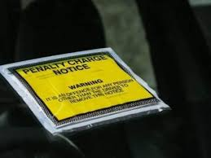 BBC Report on Car Parking Charges in the East of England

In 2024-25, 20 councils in the East of England each made more than £1m in profit from charging for on street and off-street parking.

Milton Keynes Council made £10m, the highest amount in the region, while Southend-on-Sea made £6.8m.

 Chancellors Speech (21 October) regarding the East West Corridor

The Oxford to Cambridge Growth Corridor is a world-leading innovation corridor in the UK. It is a vibrant and innovative hub for globally renowned science and technology firms and internationally successful start-ups, that contribute to and benefit from the rich ecosystem of talent and ambition in the region. It is anchored by two of the world’s best universities, producing world class research and generating hundreds of commercially successful spin outs.

The government is committed to realising the full potential of the Corridor by unlocking opportunities for new investors and businesses to join this ecosystem. This will better connect working people to jobs, create thriving communities and boost innovation and investment across the whole of the UK.

Deepening the links between Oxford and Cambridge, Milton Keynes, Bedford and beyond with significant investment into East West Rail, will ultimately connect a region of 3.5 million people - highly skilled, highly employable, and highly mobile.

The Oxford to Cambridge Investment Prospectus sets out some of the opportunities within the Corridor that are at the cutting edge of all that makes the UK an exciting place to invest.

Published 21 October 2025

 New Road Safety Officer - MKCC highways

Highways officers report that …. ‘We did have someone who started in the role but sadly they did not stay so the role is now vacant again. We will need to go through the recruitment process again now’.

 I attended the meeting of the Milton Keynes Association of Local Councils which was held on Wednesday 29th October 2025 at the Woughton Community Council Hub, The Local Centre, 60, Garraways, Coffee Hall, Milton Keynes, MK6 5EG.

There were presentations from ….

- Francesca Skelton on the role of Chair of the Milton Keynes Honours Group and Deputy Lieutenant.
- Simon Kearey on the Arts and Heritage Alliance Milton Keynes.
- Milton Keynes Parks Trust Partnership working with Parish & Town Councils



I attended the meeting of the Milton Keynes Association of Local Councils which was held on Wednesday 29th October 2025 at the Woughton Community Council Hub, The Local Centre, 60, Garraways, Coffee Hall, Milton Keynes, MK6 5EG.

There were presentations from ….

• Francesca Skelton on the role of Chair of the Milton Keynes Honours Group and Deputy Lieutenant.
• Simon Kearey on the Arts and Heritage Alliance Milton Keynes.
• Milton Keynes Parks Trust Partnership working with Parish & Town Councils
______________________________________

 White Ribbon Vigil at MK Rose - Tuesday 25th November, 6pm
Letting sexism slide puts women and girls at risk. Sexist jokes, catcalling, staring, and comments might seem harmless, but they are serious because they can lead to violence and abuse.

This White Ribbon Day, we want more men to use their voices and speak up to create a world where everyone is safe, equal and respected. Every time we ignore something that doesn’t feel right, we miss a chance to set a better example. Join us, VOWMK, Milton Keynes City Council and a host of other organisations at The MK Rose for the White Ribbon Vigil.

For 2025 Milton Keynes is holding a craft exhibition at CMK shopping centre to be opened by the Mayor of Milton Keynes at 5.30pm before its Annual Vigil at MK Rose. Please come along and support and take a moment to raise awareness, reflection and action.

Find out more here. https://www.whiteribbon.org.uk/white-ribbon-day

Group support and volunteering: support@communityactionmk.org
Networks: networks@communityactionmk.org Telephone: 01908 661623
-------------------------------------------------------------------------------------------------------------------------------
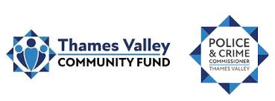 OFFICE OF THE POLICE & CRIME COMMISSIONER FOR THAMES VALLEY

The Community Fund (previously called the Police Property Act Fund) is created from
the proceeds of sale of goods recovered by the police that cannot be returned to their
original owner. In accordance with the Police Property Act Regulations (1997) all
awards from the fund must be for charitable purposes.

The Police and Crime Commissioner with assistance from the Chief Constable, has just dispensed £199K to 49 organisations. Looking through the list I can only see two from MK, Castlethorpe and New Bradwell PCs.

These distributions are made twice yearly. It would be good to seek applications from Danesborough town and parishes and Walton Community Council and I would be keen to support them.

The next round should be Spring 2026.

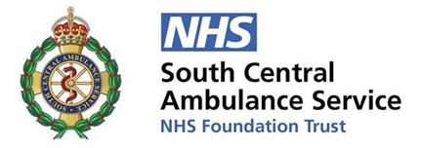 South Central Ambulance Service - Governor Elections

South Central Ambulance Service (SCAS) will be holding elections for new Governors to join its Council of Governors. The election period begins in December, with applications opening on 9 December 2025 and closing on 8 January 2026.

For details on the application process and how to vote, please visit: Governor elections | South Central Ambulance Service.

https://www.scas.nhs.uk/about-scas/council-of-governors/elections/

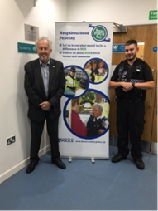Thames Valley Police Meeting - Have Your Say Community event.

The next local event planned for the following dates.

• Crime Prevention Stand
2:30PM - 4:00PM, Wed 26 November 2025
1A Bolebec Avenue, Eagle Farm South, Milton Keynes

• Crime Prevention Stand
10:00AM - 2:00PM, Sat 6 December 2025
Woburn Sands Market, Woburn Sands

More local TVP information at https://www.facebook.com/TVPMiltonKeynes

 There is a fresh drive to boost Pension Credit take-up as new figures reveal large regional gaps in those receiving benefit worth around £4,300 a year. A new trial to boost Pension Credit take up is underway after analysis showed significant regional disparities in pensioners claiming the benefit, which can be worth over £100 a week.

For more information on Pension Credit, eligibility and how to claim the benefit, please visit: Pension Credit: How to claim - GOV.UK at https://www.gov.uk/pension-credit/how-to-claim

… or call the Pension Credit claim line on 0800 99 1234.

Cllr David Hopkins
Representing Bow Brickhill at MK City Council - November 2025

