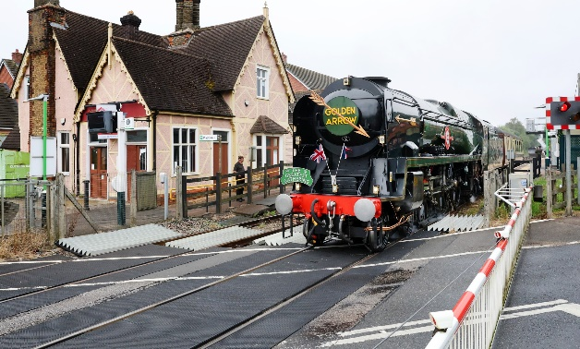 Bow Brickhill Parish Council
Update from your Unitary Councillor – September 2025


Welcome back after the summer break.

It’s time to contemplate what we can expect over the coming few months in terms of government announcements and how they will impact our local community. I was reading a piece in a national newspaper over the summer setting just how the development of Universal Studios near Kempston Hardwick will fundamentally alter our local economy here in MK transforming it into very much of a Leisure based economy offering both opportunities and challenges for us all in the coming decade.

The 2050 Local Plan (MK2050)

MK City Council comments that in the light of the many responses to the Regulation 18 plan and ongoing evidence base work, they have moved the consultation back to November - December 2025. A delegated decision to consider approving the final draft (Regulation 19) consultation and the subsequent submission of the MKCP is planned for 28 October 2025. The city council still intend to submit the plan in March 2026.

We can expect an announcement from MK City Council in late September / early October and of particular interest to Bow Brickhill will be …

- Will the land known as Levante Gate west of Bow Brickhill still be included and for 1250 dwellings?
- What designation might the city council place on the Greensand Ridge (Brickhill Woods) to protect its integrity and amenity value.
- Will the expansion areas include the expansion site south and west of Caldecotte and Bow Brickhill be included and for how many more houses (up to 1500)?

East West Rail

The government has announced that it will be making an announcement (via the East West Rail company) in November regarding much more detail relating to the project and the associated infrastructure.

It maintains that it is aware of the concerns of local people regarding the future of local stations and whether Bow Brickhill station will survive, the actual position of local stations, possible closures of level crossings and the development of bridges etc. However, being aware and listening to local people may be two different things as the terms of the Infrastructure and Planning Bill make their way towards becoming legislation …

The Infrastructure and Planning Bill

The government maintains that the purpose of the Planning and Infrastructure Bill (PIB) is to speed up and streamline the delivery of new homes and critical infrastructure projects across England and Wales by reforming the planning system. Key aims include accelerating housing approvals, minimizing delays for infrastructure, enhancing planning transparency, creating a nature restoration levy, and strengthening the powers of development corporations. The bill also seeks to address issues like water and nutrient neutrality, which have stalled development in certain areas.

In effect, the Planning and Infrastructure Bill will significantly reduce opportunities for public consultation on major infrastructure projects by removing the statutory pre-application consultation requirements for Development Consent Orders (DCOs), which include projects like roads, railways, and windfarms. This change aims to streamline the planning process, speed up delivery, and reduce opportunities for legal challenges, though it has raised concerns about reduced environmental protections and democratic accountability.

What this means in real terms is fewer opportunities to comment on planning issues, especially strategic planning issues such as East West Rail and the Local Plan.

 Highways are offering a drop-in session for MKCC ward councillors in advance of the next MKCC Full Council meeting on Wednesday 17 September so if BBPC members have highways issues they wish me to raise please let me know in advance of the meeting.
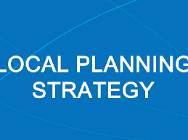 MK City Plan 2050
Following the consultation on the draft Milton Keynes City Plan 2050 (MKCP 2050) that took place between July and October 2024, we have been reviewing the comments received and updating and finalising our evidence base to shape the final draft MKCP 2050.

MKCC received around 7,000 comments on the Regulation 18 Plan and are continuing to work with stakeholders as the MKCP 2050 is being finalised. We are also checking and refining the proposed policies and allocations in the MKCP 2050. MKCP 2050 must be based on comprehensive and up to date evidence, and we cannot progress without this. As MKCC is still awaiting completion of our transport modelling, they have had to reconsider the timings for the next stages.

Previously MKCC intended to consult on a final version of the MKCP 2050 between September and October 2025, before submitting the Plan for independent examination in March 2026. While the intended submission date has not changed, we are now planning to consult on the final draft MKCP 2050 between November and December 2025.

A delegated decision to consider approving the final draft (Regulation 19) consultation and the subsequent submission of the MKCP is planned for 28 October 2025. Please see the Council’s Forward Plan for more information: Forward plan- Executive Decisions (including Key Decisions). (1 August 2025) Onwards Milton Keynes City Council https://milton-keynes.moderngov.co.uk/mgListPlanItems.aspx?PlanId=242&RP=154&

This means that we have had to rearrange the event that we had planned to hold on 10 September, this will now be held on 5 November. This event is open to both MKCC Councillors and Town and Parish Councils. The session will cover details about the final draft of the MK City Plan and its consultation. Informed by comments made during the draft Plan (Regulation 18) stage and the finalised evidence, the final draft MK City Plan 2050 (also known as Regulation 19, or ‘proposed submission’) will be published for consultation for six weeks.

Due to capacity, as before spaces will be limited to 2 attendees per Town & Parish Council, more details will be sent out nearer the time including how to register for the session.

Planning Applications and Notifications
________________________________________

Application Number: PLN/2025/1704 - Non-Material Amendment
Location: 47 CHURCH ROAD, BOW BRICKHILL, MILTON KEYNES, MK17 9LH
Proposal: Non-material amendment seeking additional first floor dormer and rooflight to ensuite, addition of rooflight over kitchen and the addition of a window in the kitchen (relating to permission ref. 23/02496/HOU for the erection of a part two storey, part single storey rear extension, and a replacement roof to existing two storey rear projection to a pitched roof, including rooflights)
Case Officer: Sonia James
Consultation Expiry: 2025-09-03
________________________________________

Application Number: PLN/2025/1762 - Permission in Principle
Location: 74A STATION ROAD, BOW BRICKHILL, MILTON KEYNES, MK17 9JT
Proposal: Proposed erection of a self-build two storey detached dwelling
Case Officer: Yu Ling Wong
Consultation Expiry: 2025-09-26
________________________________________

 Snippets
- Household Support Fund – funding for Parishes. MKCC has made a funding offer to BBPC.
- I have dealt with issues raised by residents relating to Church Road, both highways and planning issues and in support of the proposed works at the pavilion.

 Research Request

The Diffley Partnership is conducting research in Milton Keynes for a project on behalf of Santander UK and with in-kind support from MKCC. Details of the project can be found here - City Council and Santander partner to help residents improve energy efficiency | Milton Keynes City Council https://www.milton-keynes.gov.uk/news/2025/city-council-and-santander-partner-help-residents-improve-energy-efficiency

There are several elements top the research commission over 2025:
1. A large-scale public survey with Milton Keynes residents- completed in April
2. Forming a panel of Milton Keynes residents- we have over 80 MK residents in the Tomorrow’s Homes Panel
3. Research activities including in-person, online focus groups and surveys to the panel
4. Helping with a wider open day (tbc October/ November)
5. Stakeholder interviews

The Diffley Partnership would like to hear from people interested in taking part in stakeholder interviews. Some further information below

What is the research about?
This research aims to understand key barriers and potential solutions to building decarbonisation in Milton Keynes. As part of this, we are speaking to local stakeholders about these issues including members or the business community, third sector, service providers and political representatives.

Who is funding the research?
This research is funded by Santander UK and supported in-kind by Milton Keynes City Council

Who is conducting this research?
Santander UK has commissioned Diffley Partnership – an independent research organisation - to conduct this research. You can find out more about them on their website- https://diffleypartnership.co.uk/. Their research adheres to the Social Research Association’s Research Ethics Guidance. ( SRA Home | Social Research Association )

What will I be required to do?
Take part in an online or telephone interview of approximately 45 minutes to discuss your views on energy efficiency and related issues in Milton Keynes.

What happens to my information?
Diffley Partnership will analyse all the stakeholder interviews and include key themes in their final project report. All information will be anonymous, and you will not be identifiable from any of the reporting.

When?
Between now and November, Diffley Partnership would set up a time that suits you.

How to I take part?
Please contact Diffley Partnership directly on research@diffleypartnership.co.uk to make arrangements with you.

 Delays

The National Infrastructure and Services Transformation Authority has issued their annual report for 2024/25 having reviewed progress on Government projects.

The DfT spent £175.3m on East West Rail against a budget of £90.2m -a 94.3% overspend. EWR was assessed as amber with significant issues to be resolved and slower progress than anticipated and uncertainties about deliverability and funding from the Treasury. The next stages from Bletchley to Cambridge are costed at £3.97b with completion in 2030 although a Development Consent Order needs to be obtained.

The current scheme from Bicester to Milton Keynes spent £125m against a budget of £118m. There are concerns over the delays to the start of services. This was due to the delay in awarding the contract to run the services to Chiltern Railways and for agreement with the trade unions on the operation of the service which has delayed driver training. It is hoped services can still start in 2025.

(Summarised in New Civil Engineer magazine 20/8/25)
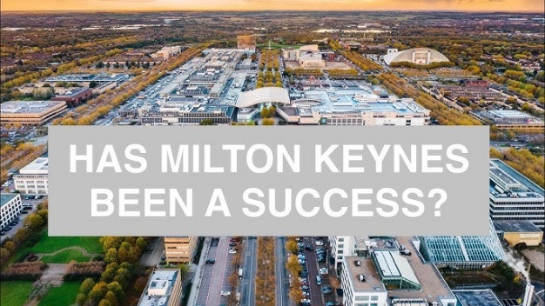 Hidden Toil Behind Shiny Fronts:
experiences of living in a new housing area with little income
OU Research Report published in July 2025

In a bid to resolve the UK’s housing crisis, the government is planning to build 1.5 million homes by 2029 and establish up to 12 New Towns before the next election. The OU sponsored research in Milton Keynes, one of the fastest growing cities and one that is often hailed as one of the most successful New Towns, reveals that new housing areas offer a two-tiered experience with low-income residents often drawing the short straw. The research draws on experiences of residents in Glebe Farm and Eagle Farm South, amongst others.
To avoid the city bursting at its seams and new housing areas trapping low-income residents in a life of precarity rather than move them out of it, the report calls on national government and local authorities to work with developers and other stakeholders to:
• Prioritise the establishment of vital services, including schools, health facilities and shops, to serve new and existing residents within reasonable distance;
• Ensure that public transport links are established as soon as new housing areas are being developed to offer affordable and viable ways of travelling around the city;
• Construct community buildings with ample capacity to meet communities’ needs, and ensure temporary facilities are provided until permanent facilities are available;
• Invest in community development to build an inclusive and thriving community;
• Hold housing associations to account for lack of responsiveness or inadequate response to faults or complaints;
• Meaningfully enable the participation of voluntary, community organisations and resident groups before and throughout the development of new housing areas to understand the needs of all residents, and especially those on lower incomes.

A copy of the full report is attached.

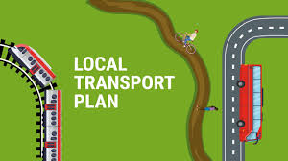 MK City Council Local Transport Plan Officers have been preparing the new Local Transport Plan 5 document for the last 18 months, in response to a Department for Transport (DfT) call for all local authorities to update their transport plans in the light of new national focus on public transport, active travel and the decarbonisation of transport.

The draft document has been developed in the context of the Council’s own plans and policies, including MK:2050 Strategy, the Sustainability Strategy and the Local Plan and in the context of wider national guidance on transport policy, such as Decarbonising Transport, and the emerging Integrated Transport Strategy.

The LTP has an extensive evidence base, which sets out our current baseline in terms of modal share and use of the transport system in MK and has also been informed by an extensive public consultation exercise which commenced in Summer 2024 which received over 5,000 responses covering all aspects of our transport system. This information, along with the councils own MK strategies and national policy guidance have been used to inform the suggested policies in the LTP5 document.

The consultation will run for a period of 12 weeks and will start in the first week of September.

MK City Council officers have been preparing the new Local Transport Plan 5 document for the last 18 months, in response to a Department for Transport (DfT) call for all local
authorities to update their transport plans in the light of new national focus on public transport, active travel and the decarbonisation of transport.

The draft document has been developed in the context of the Council’s own plans and policies, including MK:2050 Strategy, the Sustainability Strategy and the Local
Plan and in the context of wider national guidance on transport policy, such as Decarbonising Transport, and the emerging Integrated Transport Strategy.

The LTP has an extensive evidence base, which sets out our current baseline in terms of modal share and use of the transport system in MK and has also been informed by
an extensive public consultation exercise which commenced in Summer 2024 which received over 5,000 responses covering all aspects of our transport system.

This information, along with our own MK strategies and national policy guidance have been used to inform the suggested policies in the LTP5 document.

Following the consideration of the draft LTP5 document by the Environment and Place Scrutiny Committee in June, an accessible summary document for public
consultation has now been prepared and is attached.

The agreement to proceed to consultation will be made on Tuesday of next week and then an eight week consultation will commence.

Some headlines emerging from the briefing to parishes perhaps include…

• Link to MK2050 Local Plan
• The city can no longer rely on country lanes
• The network is decaying – especially bridges
• Stronger parking enforcement is planned
• All parking surplus monies will be invested in transport
• Plan to reduce grid road speeds
• Plan to introduce average speed cameras
• MKCC will obtain camera enforcement powers in November of this year
• Car cruising is a major issue – operation Chromium addressing the issues with TVP
• MK Metro network in place by 2030 (see slide above and the document itself)
• MK Connect will have driverless vehicles in the near future with enormous cost savings enabling expansion of the network
• New Towns Taskforce discussing with MKCC funding of the new MK Connect Services
• Council planning to take on transport franchising powers can offer cross subsidised services
• Smart ticketing is coming
• And finally chord … which is apparently the project that will enable trains coming from MK Central to join the East West Rail network without reversing or people having to change trains (Denbigh Hall Junction project)

Details attached.

 On Sunday 7 September at around 3pm, anyone with a mobile phone in the UK will be sent a test emergency alert by Government. Beyond the tests, the alert system will sound when there’s a risk to life, such as extreme weather. It will be a loud, siren-like warning on your mobile with details of the risk and instructions on what to do. https://www.gov.uk/government/news/national-emergency-alert-test-to-be-held-on-7th-september

It is possible to opt out of the alerts. It’s not generally recommended but might be useful for some people, e.g. those living with an abusive partner who keep a secret secondary mobile – there’s details on how to do so here. https://www.gov.uk/alerts/opting-out
________________________________________

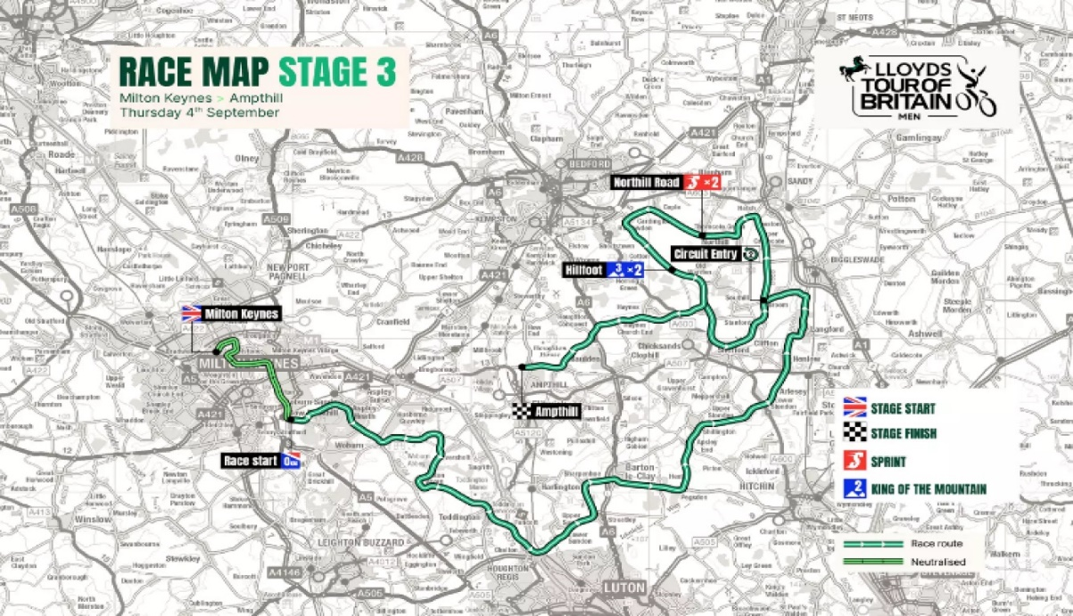 Tour of Britain Cycle Race
The Lloyds Tour of Britain is the largest free-to-attend sporting spectacle in the UK. Thursday 4 September saw stage three of Britain’s biggest professional cycle race starting in Milton Keynes; a 122.8-kilometre (76.4-mile) leg from Milton Keynes to Ampthill, that will take in Woburn, Toddington, Barton-le-Clay, and Shefford, and include a spectator friendly double-loop around Northill and Old Warden.

Stage three got underway from Milton Keynes’ Midsummer Boulevard at 11:30, where special activities will be happening for spectators, crossing Campbell Park before heading south on grid roads, leaving the H7 Chaffron Way for a long stretch on the V10 Brickhill Street, passing the Open University headquarters and the Oracle Red Bull Racing Formula One technology campus before racing to Bow Brickhill, Woburn Sands and on into Central Bedfordshire. The stage finishes in Ampthill town centre at around 14:40.

In celebration of the Tour, local cycling firm Madison is offering two adult and two child Ridgeback bikes worth over £1,700.

To enter, you’ll need to share your favourite photo of cycling in MK here: www.destinationmiltonkeynes.co.uk/cycling-photography-competition/.

 Heritage Open Days Milton Keynes

Free Events 12 - 21 September 2025

A reminder that 2025 is the 19th year that the Milton Keynes area has celebrated Heritage Open Days. In 2006 there were 15 events held across MK – this year we have 250 events to showcase our distinctive and world class heritage, arts and culture. The national theme this year is Architecture, and this icon highlights the 109 events.

From the 12th to the 21st of September there are TEN DAYS of unmissable events taking place, including many activities for children and families. There are opportunities to come along to exhibitions, workshops, walks and tours, open days, craft events and performances. Suitable for all ages. And all events will be FREE.

For further details visit: Events Archives - Living Archive

https://www.livingarchive.org.uk/events/category/events

Parishes Forum
Online via Microsoft Teams
11 September 2025
18.00 – 20.00

MKCC welcome local councils’ participation and hope as many parishes can join us and take part in discussions.

1. Welcome and Apologies 18:00
1.1 Apologies for absences
1.2 Notes from previous meeting

2. Milton Keynes University Hospital 18.05
Lui Straccia (Membership and Engagement Manager)

3. Drug and Alcohol Family Support (DAFS) 18.35
Lynn Fox
Valerie Forsey
4. Early Years / Youth Services and Family First 19.00
Garry Lake (Strategic Lead for Early Help)

5. Parish Successes 19.40
(Delia Shepherd – Clerk, Bletchley and Fenny Stratford Town Council)

6. Good News and Hot Issues 19.55

7. Date of Future Meetings

• 4 December 2025
• 12 March 202

Cllr David Hopkins - Representing Bow Brickhill at MK City Council (September 2025)

