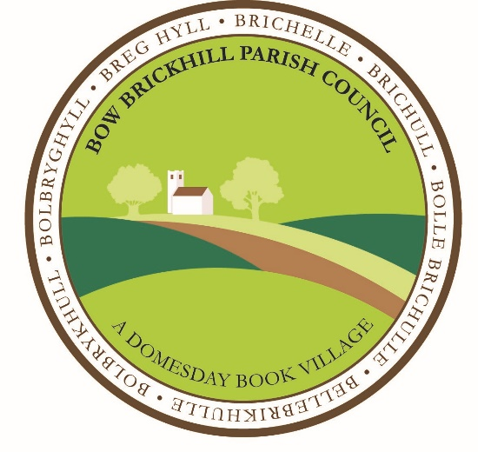
BOW BRICKHILL PARISH COUNCIL

New City Plan

Response to the Consultation Document
Movement
The Parish Council welcomes the idea of developing a Mass Rapid Transport network but care should be taken that this is accessible to outlying areas of the City. This was after all in the original plan for Milton Keynes to have a monorail system but costs meant it was never built. Bow Brickhill currently has no rail service and a very limited bus service.
Residential properties in urban areas have been found to enjoy a boost in property value if they are located near transportation centres, such as train stations or Mass Rapid Transport networks. Ultimately, this is due to the level of convenience these services provide. In situations where residents are unlikely to have their own form of transportation, such as a car, easy access to public transit can markedly increase demand for accommodation in a prime location.
Careful identification of congestion points in the City’s grid system with a view to dualling these roads should be undertaken. In many cases, the land is available already.
Walking and cycling are transport activities which need to be encouraged and made easily available to residents and visitors. Some areas of the City, for example Bow Brickhill are not connected to the redway system or do not have redways flowing through.
Housing growth and regeneration
Whilst the Parish Council understands that if the City is to be expanded, more sites for building new houses need to be found, we are concerned that the smaller villages are likely to be swamped. These villages, Bow Brickhill among them were one of the original attractions of the new city when it was being built. Bow Brickhill has made its contribution to help meet the local housing need quota of 1900 with almost 100 new builds given planning permission in the last 8 years. There is also to be a massive development of 3,000 homes in the Milton Keynes South East area between Wavendon, Woburn Sands and Bow Brickhill. We are alarmed that the New City Plan talks of further sites being identified. We strongly urge the City Council to take great care in choosing which areas are earmarked for further development.
Economic Growth
Continuing a pattern of strong economic growth is paramount to the continued success of Milton Keynes. Building more warehouses will only improve economic growth marginally and there is an argument to say that it actually reduces growth.
One of the biggest concerns that homeowners have when commercial developers begin purchasing plots of land close to them is whether or not the projects planned will significantly increase the amount of vehicle traffic in the area. A surefire way to hurt property values and reduce buyer interest in neighbourhoods is to make them hard to access due to constant traffic.
A significant increase in the number of individuals near a residential area could also deter new parents who may be seeking a neighbourhood that is safely isolated from denser areas. Bow Brickhill is about to experience the effects of a massive and inappropriate warehouse development at South Caldecotte. We strongly urge the City Council not to pursue a policy which will end up making Milton Keynes a warehouse City. That would be a far cry from the green and beautiful City we all want to see.
The City Council should set up a special unit to target blue chip companies like Santander and Red Bull to come and make their headquarters in Milton Keynes. This was a considerable success when the City was being built.
Central Milton Keynes
The Parish Council applauds any initiative which will look at how the City Centre can be grown to cater for the leisure and retail opportunities a potential population of half a million people will require. The theatre district should be included in a review which will build on its success to date and this should also include providing international restaurants to rival London.
Commercial properties can provide an ambiance and unique cultural atmosphere that add an indefinable "polish" to an area, which attracts residents. With that in mind, it is quite likely that a collection of quality restaurants, clubs and shops may raise the demand for accommodation throughout the area in general.
Infrastructure
Adequate health services are going to be vital to the new city and Infrastructure before Expansion should be the watchwords of a new city plan. Consideration should be given to either expanding the current hospital or building another one. Doctors surgeries and ancillary healthcare services must be prioritised in view of the expansion envisaged.
Schools are another major area of concern, but again they need to be built before development takes place not as an afterthought.
Green City
The Parish Council believes it is vital both to maintain the current network of parks, lakes, rivers and canals and to insure there is adequate provision of new green spaces. The redway system needs to be maintained and enhanced with more encouragement to use these facilities and to contribute to the goal of carbon emissions neutrality.
Beautiful City
Whilst the Parish Council strongly agrees that our valued historic environments and buildings should be protected, allowing unbridled development in small villages like Bow Brickhill will seriously undermine this goal. Developers need to be made much more aware of environmental and local concerns than we have seen to be the case hitherto.

Julian C Price
Chairman, Bow Brickhill Parish Council
15th March 2023

